Fundamentals of Heart Sounds

Production

Heart sounds are produced by two main mechanisms: 1) Sudden acceleration (or deceleration) of blood flow created by the opening and closing of cardiac valves or the tensioning of the heart's internal structures (e.g. chamber walls, or papillary muscles). 2) Turbulent blood flow created by unilateral protrusion into the blood stream, high flow rates, flows into abnormally large or small chambers or circumferential narrowing.

Abnormal heart sounds and murmurs can be found in infants or develop later in life.

Audio

Stethoscopes are used for auscultating heart sounds, often with chestpieces that include both a bell and a diaphragm.

Normal heart sounds resemble "Lub-Dub". These are the sounds of your heart valves closing normally. In some patients, the "Lub-Dub" sound is different, often with additional sounds being heard.

Heart Sounds and Murmurs

This fundamentals module for heart sounds and murmurs provides an overview of heart sound characteristics followed by lessons on twelve selected sounds. Each lesson includes text, heart sound recording and an anatomical animation of the heart producing the sound. These lessons are described below and also listed in the table of contents.

This website provides additional auscultation courses, reference guides, and quizzes. Certificates of achievement are also available.

Timing

Systolic murmurs occur after the first heart sound (S1) and before the second heart sound (S2). Diastolic murmurs occur between S2 and S1. In our lessons, timing phrases will be used to explain when murmurs occur within systole or diastole. For example, early systolic, midsystolic or late systolic.

Heart Sounds Location

Auscultation of heart sounds should be conducted carefully over at least five locations on the anterior chest wall. See the associated illustration for these locations. Many stethoscopes have chest piece with both bell and diaphragm. Typically, start with the diaphragm but switch to the bell to hear lower-pitched sounds.

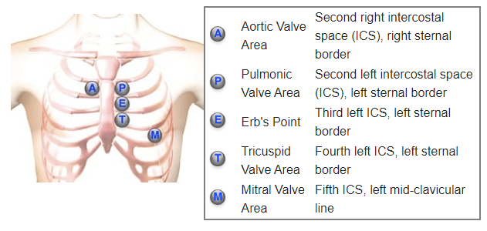

Sound Duration

Heart murmur duration refers to the length of time of the sound. First and second heart sounds are short, while murmurs are typically longer. Murmurs lasting throughout systole are described as holosystolic or pansystolic.

Murmur Pitch

A heart sound's pitch (frequency) is an important characteristic. The observer should classify the sound or murmur's pitch as low, medium, or high. The stethoscope's bell can be helpful with low-pitched sounds, while the diaphragm should be used for medium or high-pitched sounds.

Loudness Patterns

Heart murmurs are sometimes described by the pattern of the sound's loudness. Common classifications include crescendo (increasing intensity), decrescendo (decreasing intensity), crescendo-decrescendo (increasing then immediate decreasing intensity). Crescendo-decrescendo may be termed diamond-shaped. Finally, a heart murmur of constant intensity may be termed rectangular. Our lessons include waveforms images and videos that illustrate these loudness patterns.

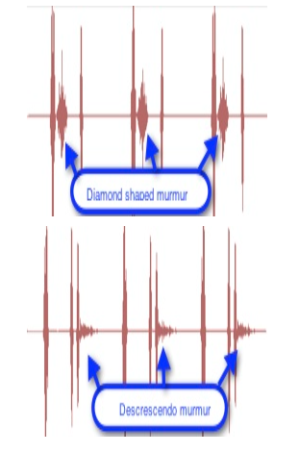

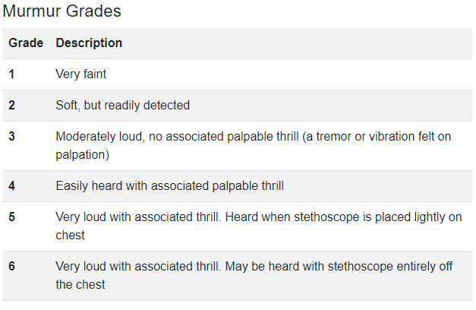

Tonal Quality

Additional aspects of the murmur's sounds can be used to characterize a murmur using terms such as musical, harsh, blowing, booming, sharp, or dull.

Patient Position and Respiration

Patient position and the respiratory cycle can alter heart sound splitting and murmur intensity. For each sound, we display the preferred patient position for auscultation.

Using Auscultation Lessons

Here we provide an example of a murmur. In this case, Aortic Stenosis.

Playback

Click the playback button on the torso to hear a short recording.

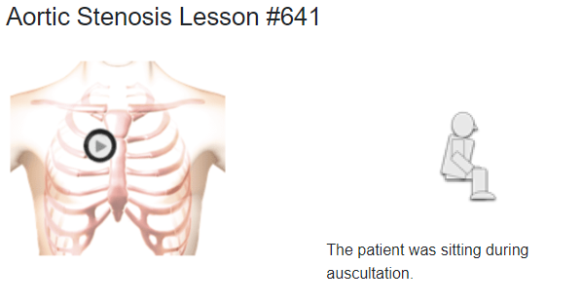

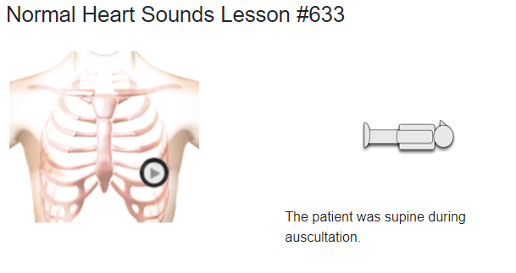

When the aortic and pulmonic valves close, sounds are created. Normally a combined sound is heard, which is the second heart sound (S2). If these two components can be individually distinguished, the condition is called a physiological split.

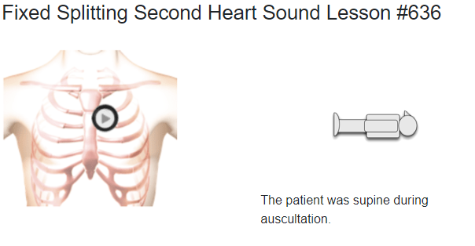

When the separation of the two components of the second heart sound remains unchanged through inspiration, the split is called a fixed split.

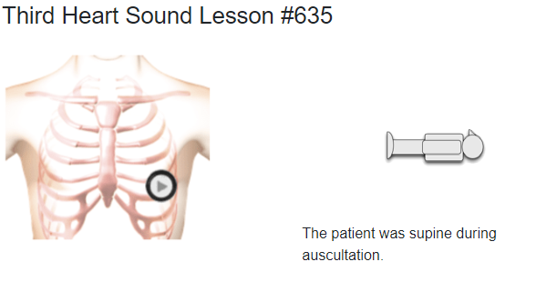

A third heart sound (S3) occurs early in diastole, just after the second heart sound. S3 is a low-frequency sound best heard using the bell of the stethoscope pressed lightly on the skin of the chest. Position the chestpiece at the left lateral sternal border (LLSB) or xiphoid area.

Sudden deceleration of blood flow into the left ventricle from the left atrium causes the third heart sound.

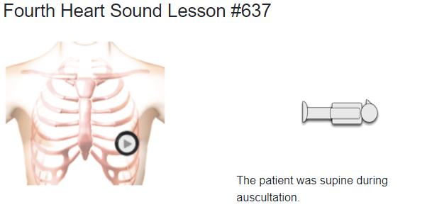

The fourth heart sound occurs in late diastole, just prior to the first heart sound. The fourth heart sound is a low-frequency sound best heard with a chestpiece bell pressed lightly onto the skin.

The fourth heart sound occurs during the diastolic filling phase, created by increased stiffness of the left ventricle, decreased ventricular compliance, or by increased volume. This may be a manifestation of heart disease

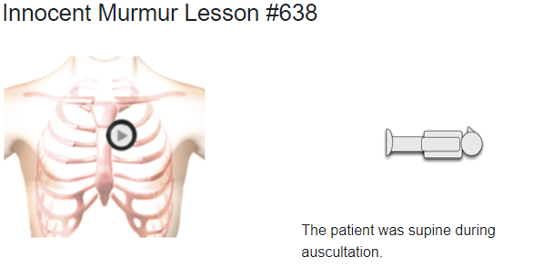

Innocent murmurs are benign continuous sounds observed in pediatric patients with non-cardiac conditions such as pregnancy, hyperthyroidism, exercise, and anemia. When treated appropriately, the systolic murmur disappears.

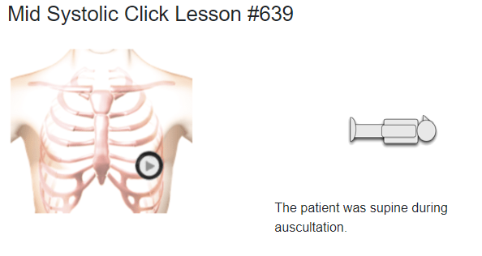

The mid-systolic click is usually created by the sudden prolapse of the mitral valve leaflet into the left atrium. The anatomy video illustrates this mitral valve posterior leaflet prolapse.

Listen to the recording of a mid-systolic click recorded at the apex. The first and second heart sounds are normal, and no murmur is present.

In some cases, a late systolic murmur follow the mid-systolic click.

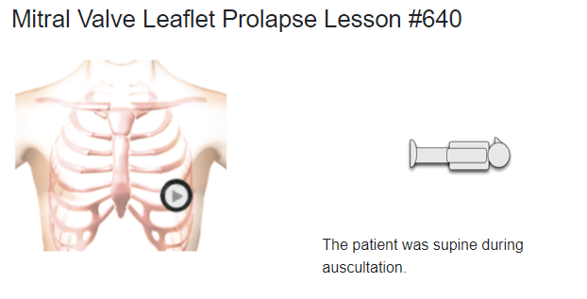

In this case, a mid-systolic click is immediately followed by a late systolic diamond-shaped murmur that runs to the end of systole. The intensity of the murmur increases and its starting point begins earlier in systole as left ventricular volume decreases (going from supine to standing).

On the anatomy video you can see that the murmur is caused by the prolapse of the posterior mitral valve leaflet. The murmur is represented by turbulent flow from the left ventricle into the left atrium.

This case presents a diamond-shaped systolic murmur associated with aortic stenosis. The first and second heart sounds are normal. The murmur starts in systole, shortly after the first heart sound and ends before the second heart sound.

The murmur is mid to high-pitched and is usually auscultated with the chestpiece diaphragm.

The anatomy video shows a markedly thickened left ventricle. The aortic valve leaflets are thickened and immobile. The murmur is caused by turbulent flow across the stenotic aortic valve.

Aortic regurgitation produces a decrescendo murmur starting early in diastole. The first and second heart sounds are normal. The decrescendo murmur is high-pitched.

Aortic diastolic murmurs can be heard at the right sternal border, third and fourth intercostal spaces.

The anatomy video shows an enlarged left ventricle with normal contractility. Observe the regurgitant flow from the aorta into the left ventricle, which causes the murmur.

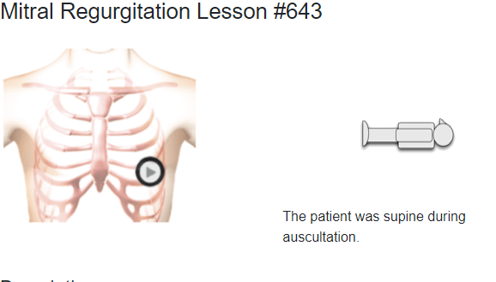

This case presents an example of a pansystolic murmur usually associated with mitral regurgitation.

The murmur is a mid-frequency, rectangular murmur taking up all of systole. S1 is normal. S2 is single. There is a third heart sound gallop in diastole. Both the left ventricle and the left atrium are enlarged. The murmur is caused by turbulent flow through the incompetent mitral valve leaflets into the left atrium.

In the anatomy video, observe the enlarged left ventricle and left atrium and turbulent flow from the left ventricle into the left atrium, creating the murmur.

This case presents an example of moderate mitral stenosis. The first heart sound is increased in intensity, while the second heart sound is normal and unsplit. A diamond-shaped low-frequency murmur follows the opening snap. There is a second murmur in late diastole caused by the contraction of the left atrium. Use the bell of the stethoscope to hear this murmur.

In the animation, observe the turbulent blood flow from the left atrium into the left ventricle. Also, observe the moderately thickened mitral valve leaflets and the moderately enlarged left atrium.

This condition is most commonly due to rheumatic heart disease.

Lung Auscultation Locations

Auscultation of lungs sounds should be conducted over the anterior and posterior chest walls. See the associated illustration for these locations. Many stethoscopes have chestpieces with both bell and diaphragm. Typically, start with the diaphragm but switch to the bell to hear lower-pitched sounds.

The **triangle of auscultation**, found on the dorsum of the thorax, has a relatively thin layer of muscle. This makes it an ideal location for lung sound auscultation. You should ask the patient to cross their arms and lean forward.

Timing and Duration

During auscultation, note the sound's timing within the respiratory cycle such as inspiratory, expiratory or more specific terms such as early expiratory.

Pitch

A lung sound's pitch (frequency) is an important characteristic. The observer should classify the sound or murmur's pitch as low, medium, or high. The stethoscope's bell can be helpful with low-pitched sounds, while the diaphragm is used for medium or high-pitched sounds.

Using Our Auscultation Lessons

Here we provide an example of lung sounds, a fine crackle.

Playback

Click the playback button on the torso to hear a short recording.

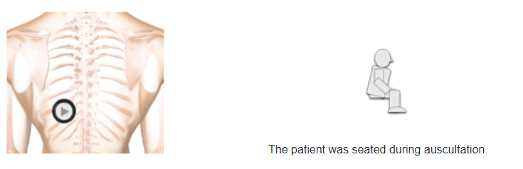

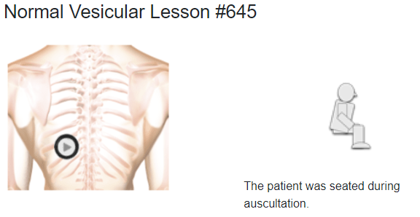

Bronchial breath sounds are hollow, tubular sounds that are higher-pitched compared to vesicular sounds. They can be auscultated over the trachea and anteriorly along each side of the sternum, from the second to fourth intercostal spaces. Posteriorly, along the vertebral column from the third to sixth intercostal spaces.

The stethoscope's diaphragm should be used for these breath sounds. There is a distinct pause in the sound between inspiration and expiration. I:E ratio is 1:3.

Bronchial breath sounds are hollow, tubular sounds that are higher-pitched compared to vesicular sounds. They can be auscultated over the trachea and anteriorly along each side of the sternum, from the second to fourth intercostal spaces. Posteriorly, along the vertebral column from the third to sixth intercostal spaces.

The stethoscope's diaphragm should be used for these breath sounds. There is a distinct pause in the sound between inspiration and expiration. I:E ratio is 1:3.

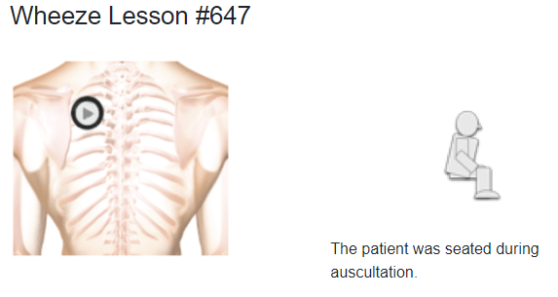

Air flowing through a narrowed bronchus produces wheezes. Accordingly, these sounds will have their highest sound intensity when auscultating over or near the central airways.

Wheezes are adventitious lung sounds associated with secretions, obstructions, tumors, or airway compression. They are continuous sounds with a musical quality. High-pitched wheezes have a squeaking quality, while low-pitched wheezes are similar to snoring or moaning. The proportion of the respiratory cycle occupied by the wheeze roughly corresponds to the degree of airway obstruction.

Wheezes are also classified by when they appear in the respiratory cycle, e.g. inspiratory wheezing or a late expiratory wheeze, and by additional information about the sound quality (monophonic or polyphonic). These characteristics can be found in our Intermediate Lung Sounds module.

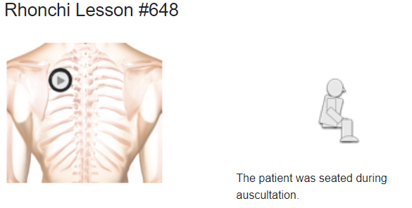

Rhonchi are continuous and low-pitched adventitious lung sounds caused by fluids or secretions in the large airways. They often have a snoring, gurgling, or rattle-like quality. They are heard primarily during expiration, but in some patients, rhonchi will also appear during inspiration. Rhonchi will usually clear or alter in sound after coughing.

Fine crackles are brief, discontinuous, popping, high-pitched breath sounds. These sounds are also similar to the sound of Velcro fasteners being pulled apart or cellophane being crumpled. Crackles can appear throughout the respiratory cycle.

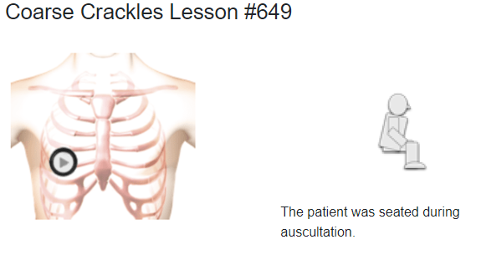

Coarse crackles are discontinuous, popping, or bubbling breath sounds. They are louder, lower in pitch, and of longer duration than fine crackles.

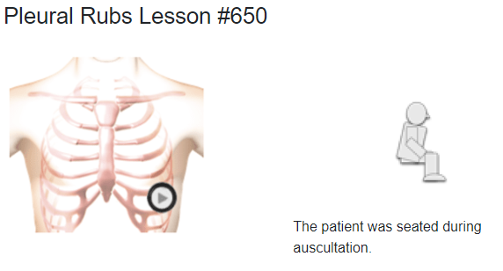

Pleural rubs are creaking or grating sounds. The sound is similar to leather against leather or walking on fresh snow on a cold day. Coughing will not alter the sound.

Pleural rubs can be generated when two inflamed surfaces are sliding by one another, such as in pleurisy. During auscultation, pleural rubs can be localized to a specific point on the chest wall. These sounds occur with movement of the patient's chest and will stop when the patient holds her breath. They appear on inspiration and expiration. Should the sound continue when the patient holds her breath, it may be a pericardial friction rub.

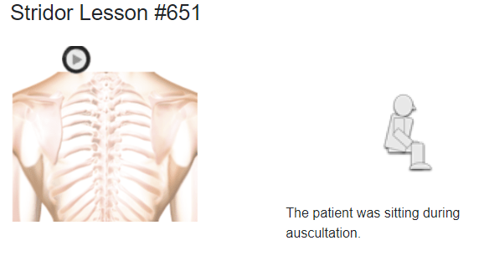

Stridor is generated by air flowing through an upper airway that is narrowed or obstructed. It occurs in 10-20% of extubated patients. Stridor is a loud, high-pitched crowing breath sound heard during inspiration. Stridor may also occur throughout the respiratory cycle, particularly if the condition worsens. Often it can be heard without a stethoscope. Causes of stridor are obstructions, pertussis, croup, epiglottis, aspirations.